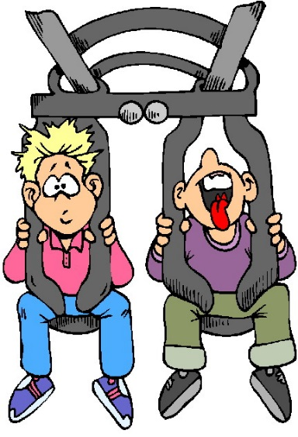
Worlds of Fun

Attention all High School Youth
& Current 7th & 8th grade students!
Join your friends for the annual trip to
Worlds of Fun.

Wednesday, June 1, 2017

7:00 a.m. – 9:30 p.m. (Check in time 6:30 a.m.)

$80 which includes bus, gate admission,
all day drink pass, and lunch

St. Robert Bellarmine Church - buses will meet and return
11900 Pacific Street (meet in cafeteria)
Worlds of Fun – Kansas City, MO

Deadline – April 21, 2017

**Late registrations will be taken from April 22 - 28, the cost is $90.00.
Registration will only be accepted if there is space!

There is limited space on the bus –
return permission form and money as soon as possible.
Spaces will not be reserved without form and money.

Registrations will not be accepted after April 28!

Make checks payable to
Mary Our Queen Youth Group.
Register early, spaces on the bus fill up quickly.

Contact Jordan Moser for more information at
402-333-8231 X 1209 or jemoser@archomaha.org

Mary Our Queen - Youth Ministry Event Permission Form

Jordan Moser – Coordinator of Youth Ministry | Mary our Queen | Phone - 402-333- 8231
jemoser@archomaha.org | 3535 S 119th St., Omaha, NE 68114

Participant’s Name |  | Name of School
Date of Birth |  | Grade this year
Participant’s E-Mail |  | Participant’s Cell Phone
Parent/Guardian Name(s) |  | Parent/Guardian E-mail
Street Address |  | City, State & Zip
Home Phone Number

I, |  | Grant permission for my youth,
 | (Printed Parent or Guardian name) |  | (Printed Youth’s Name)
to participate in this Mary Our Queen Youth Ministry event that is located away from the parish. A brief description of the event follows:

Event: | Worlds of Fun
Location: | Kansas City
Date and Time: | June 1, 2017 6:30 a.m. – 10:00 p.m.
Transportation: | Coach Bus
Cost: | $80

Name of physician |  | Office Phone
Insurance company |  | Policy Number
Any existing medical conditions an emergency physician would need to know (allergies, drug reactions) YES or NO
Explain

I hereby authorize a representative of Mary Our Queen Youth Ministry to take my child to a physician or facility for medical treatment in the event of an emergency in which neither a parent nor the adult in whose care the minor has been entrusted can be reached. If the above named physician cannot respond, I authorize any physician or medical centers to treat my child.

If a parent or guardian cannot be reached, whom should we notify?
Name |  | Phone Number

I agree that my child shall abide by the rules and regulations outlined in the Mary Our Queen Youth Ministry Code of Behavior. I have reviewed it and discussed the Code with my child prior to signing this form. I agree that if my child fails to consistently abide by the Code or engages in a serious infraction of the Code, he or she may be immediately dismissed from the Mary Our Queen Youth Ministry sponsored program and sent home at my expense.
As parent and/or guardian, I remain legally responsible for any personal actions taken by the above named minor. I agree, on behalf of myself, my child named herein, or heirs, successors, and assigns, to hold harmless and defend Mary Our Queen, it’s officers, directors and agents, the Archdiocese of Omaha, chaperones, or representatives associated with the event arising from or in connection with my child attending the event or in connection with any illness or injury or cost of medical treatment in connection therewith, and I agree to compensate the parish, its officers, directors and agents, the Archdiocese of Omaha, chaperones, or representatives associated with the event for reasonable attorney’s fees and expenses arising in connection therewith.

The Code of Behavior has been developed to help all participants have a fun and safe event. Read through the Code thoroughly. All participants will be expected to adhere to it when with us. Code of Behavior can be found at www.maryourqueen.com – Youth Ministry tab.
Parent or Guardian I agree to the above statements:

Parent/Guardian Signature |  | Date
Youth Participant: I understand and agree to the St. Robert Bellarmine Youth Ministry Code of Behavior. I also understand that my parent(s)/guardian will be notified for any event requiring my dismissal from the program and that transportation will be at their/my expense.
Youth Signature |  | Date
For Parents: I am able to help chaperone (circle one) |  | YES or NO

All Forms are due to the Youth Ministry Office on or before April 21, 2017

